Project Report: Resistor Color Code Decoder
Course: Python Essentials (Evaluated Course Project)
Student Name: Ayush Tripathy
Registration Number: 25BEC10096
Submission Date: March 31, 2026

1. Problem Statement
In electronics, resistors are marked with specific color bands to indicate their resistance value and tolerance. For students and hobbyists, manually decoding these colors using a chart can be time-consuming and prone to human error, especially when dealing with 4-band or 5-band resistors.
The problem I chose to solve is to automate this process by building a Python-based Resistor Color Code Decoder. This tool allows a user to input color names and instantly get the resistance value in Ohms (Omega) along with the tolerance percentage.
2. Why It Matters
As an Engineering student, I frequently work with hardware components in labs. Small errors in reading resistor values can lead to circuit failures or damaged components. This project matters because:
- It provides an accurate and instant way to verify components.
- It demonstrates how Python programming can be applied to solve practical, domain-specific problems in Electronics and Communication Engineering.
- It eliminates the need to memorize or carry physical color-code charts.

3. Approach to Solving the Problem
I followed a modular approach to build this solution using Python:
- Data Structuring: I used a Python Dictionary to store the mapping of colors to their respective digit, multiplier, and tolerance values.
- Input Handling: I implemented a user-friendly input system that accepts color names as strings.
- Logic Implementation: * For the first two/three bands, the digits are concatenated.
  - The third/fourth band acts as a multiplier ($10^n$).
  - The final band determines the tolerance.
- Output: The script calculates the final value and prints it in a readable format
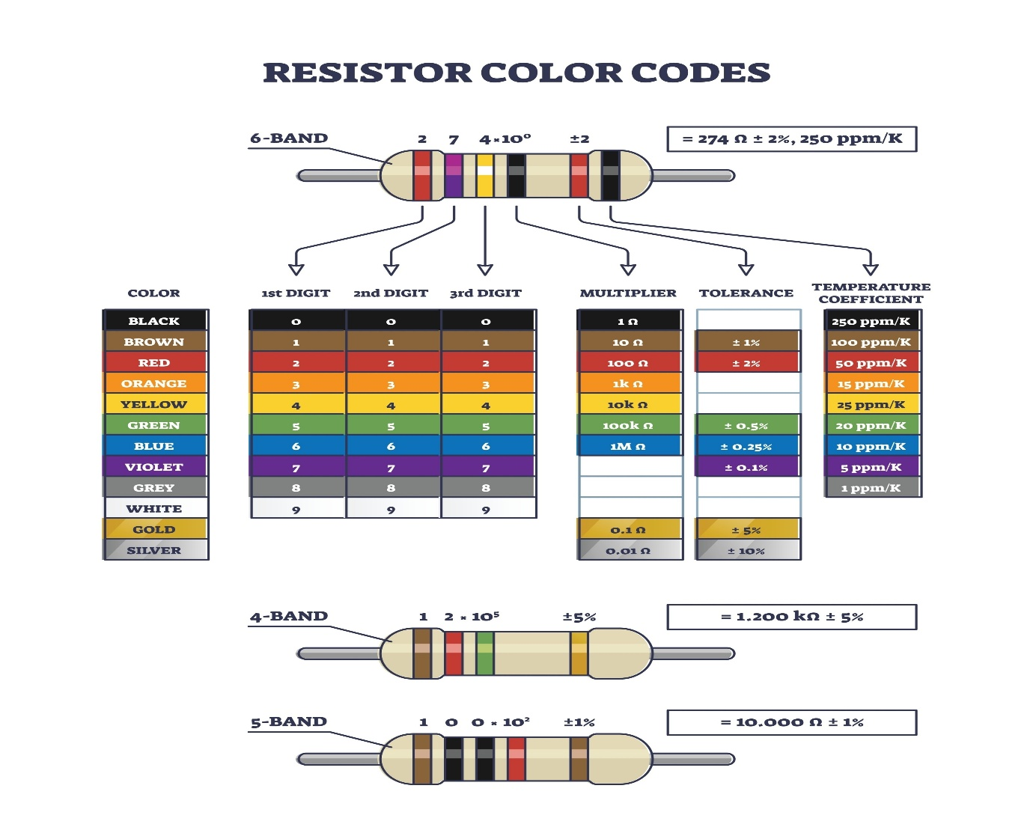

4. Key Decisions Made
- Choice of Data Structure: I decided to use a Nested Dictionary because it allows for O(1) time complexity when looking up color values, making the program very efficient.
- Error Handling: I added a validation check to ensure that if a user enters an invalid color (like "Purpleish"), the program prompts them to enter a valid color from the standard list instead of crashing.
- Scaling: I designed the code to be easily upgradable from a 4-band decoder to a 5-band or 6-band decoder by simply changing the input logic.
5. Challenges Faced
- String Formatting: Initially, the output was showing very long decimal numbers. I solved this by using Python's f-strings and rounding functions to display values in a cleaner format
- Case Sensitivity: Users might type "RED", "red", or "Red". I handled this by using the .lower() method on all user inputs to make the program case-insensitive.
- Logic for Multipliers: Implementing the power of 10 logic (10^x) required careful use of the ** operator in Python to ensure the math was precise.
6. What I Learned
This project helped me move beyond basic syntax and understand the "Logic-to-Code" transition. Specifically:
- I learned how to use Dictionaries effectively for real-world mapping.
- I improved my skills in Conditional Logic and User Input Validation.
- I realized that even a small Python script can save significant time in a laboratory environment.
- I learned the importance of Documentation (README and Comments) so that others can run my code without confusion.

7. Conclusion
The Resistor Color Code Decoder is a simple yet purposeful application of Python Essentials. It successfully solves a common task in electronics and serves as a foundation for building more complex engineering calculators in the future.

